Lab 06 - Implement Traffic Management

#### Task 1: Provision the lab environment

In the first task we need to deploy four virtual machines into the same Azure region and the first two need to reside in a hub virtual network, while each of the remaining two need to reside in a separate spoke virtual network.

So for resolving this task, a resource group is created, 2 files are uploaded for creating three virtual networks and four Azure VMs into them and a Network Watcher extension is installed. Commands in PowerShell are used for this steps.

The final result of Task1 is shown in the following picture:

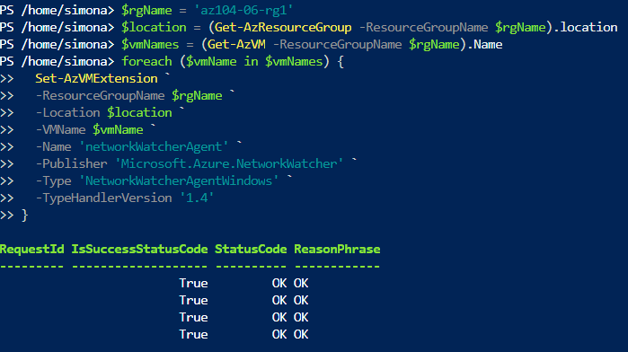

#### Task 2: Configure the hub and spoke network topology

In this task a  local peering is configured between the virtual networks that I have deployed in the previous task. The Virtual Networks created in task 1 are shown below:

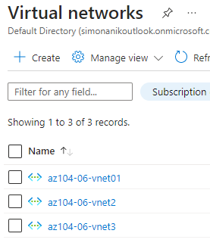

Next two local peerings are established - one from az104-06-vnet01 to az104-06-vnet2 and the other from az104-06-vnet2 to az104-06-vnet01. The required settings:

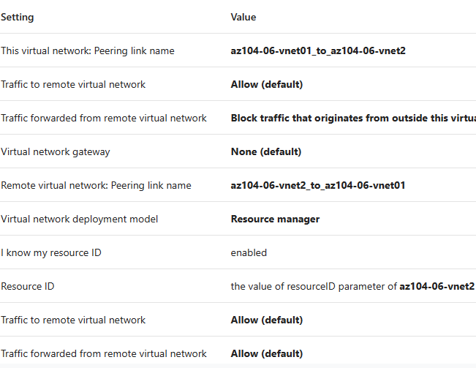

And the result:

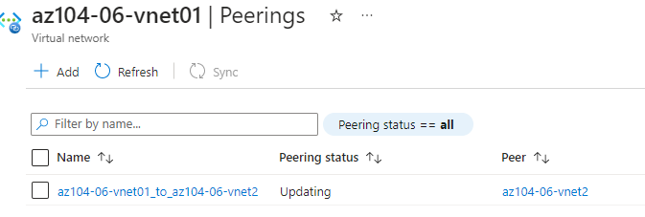

Next another peerings are established-  one from az104-06-vnet01 to az104-06-vnet3 and the other from az104-06-vnet3 to az104-06-vnet01. This completes setting up the hub and spoke topology (with two spoke virtual networks)

#### Task 3: Test transitivity of virtual network peering

In this task we test transitivity of virtual network peering by using Network Watcher. In the lab for the VM should be **az104-06-vm0 for** initiate a check On the**Network Watcher - Connection troubleshoot**blade but in my case it doesn’t gave me that VM instead it shows me vm2 and vm3 and if we check for them  the status is **Unreachable** since the two spoke virtual networks are not peered with each other. So to test between vm2 and vm0 I have found the private IP address of vm0(10.60.0.4) and after checking the result is Success

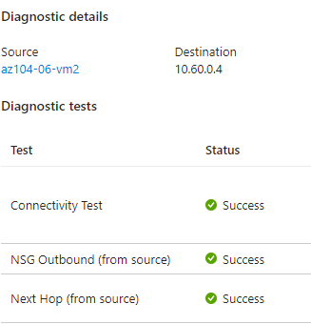

#### Task 4: Configure routing in the hub and spoke topology

In this task we need to configure and test routing between the two spoke virtual networks by enabling IP forwarding on the network interface of the **az104-06-vm0** virtual machine, enabling routing within its operating system, and configuring user-defined routes on the spoke virtual network

First we need to enable IP forwarding in order for **az104-06-vm0** to function as a router, which will route traffic between two spoke virtual networks.

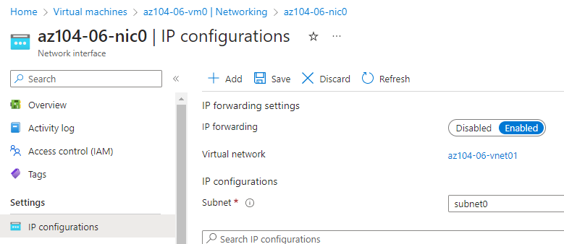

Next is configured operating system of the **az104-06-vm0** virtual machine to support routing, installed the Remote Access Windows Server role, Routing role service and  user defined routes. All this is done with commands in PowerShell. Next Route Tables are created with following settings:

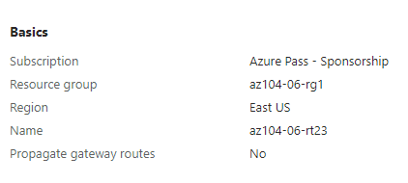

Then route is added in rt23 and a subnet is associated

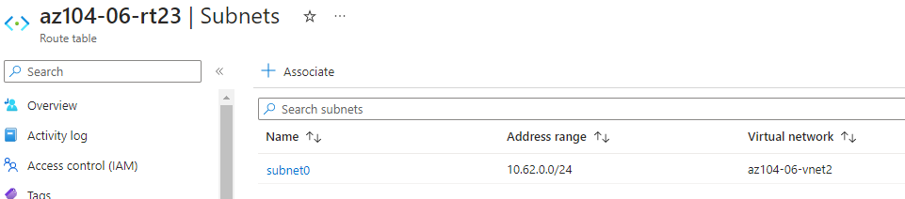

Then again is used Network Wacher for checks

#### Task 5: Implement Azure Load Balancer

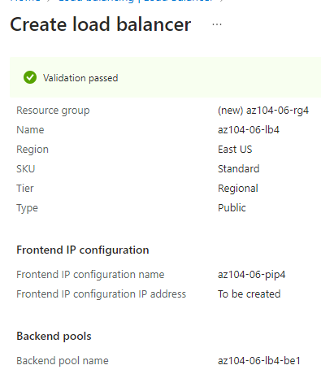

When the deployment is done we go to the resource and we can see IP address and if we open it in browser it displays this:

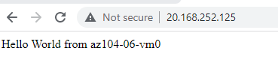

And if we refresh the window we can verify that the message changes to the other virtual machine. This demonstrates the load balancer rotating through the virtual machines.

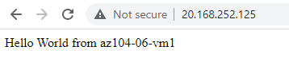

#### Task 6: Implement Azure Application Gateway

First a subnet is added to vnet01 then gateway is created with the following settings:

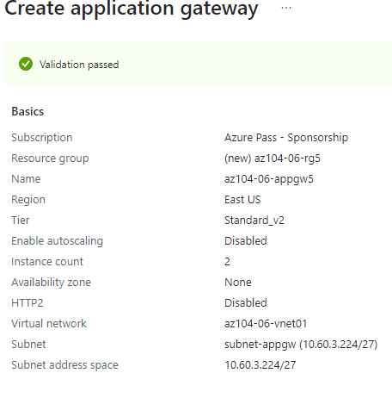

Then again we have IP address- Frontend public IP and again we open in browser and it switches between vm2 and vm3

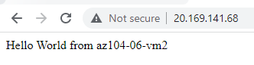 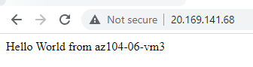

At the end all created resources for this lab are deleted.